**Aim:** Create a simple web page with headings, paragraphs, lists, and images.

**Source Code:**

<!DOCTYPE html>

<html>

<head>

<meta charset="utf-8">

<meta name="viewport" content="width=device-width, initial-scale=1">

<title>Types of lists</title>

<style type="text/css">

.mycolor{

color: green;

font-size: 20px;

}

</style>

</head>

<body background="C:\Users\dwive\Downloads\381891.jpg"

style="background-repeat: no-repeat; background-size: cover; opacity: 100;">

<!-- HEADINNG TAGS -->

<h1 style="color: rgb(235, 243, 156);"> Most Important Heading </h1>

<h2>This is heading 2</h2>

<h3>This is heading 3</h3>

<h4>This is heading 4</h4>

<h5>This is heading 5</h5>

<h6>Least Important Heading </h6>

<p>-------------------------------------------------------------------------</p>

<!-- PARAGRAPH TAG -->

<p style="font-size: 20px; ">Computers and programs are everywhere in<br>

today's world. Programs affect many aspects<br> of daily life and

society as a whole. People<br>

depend on programs for communication, shopping,<br>

entertainment, health care, and

countless other needs. </p>

<p>-------------------------------------------------------------------------</p>

<!-- ORDERED AND UNORDERED LISTS -->

<ol>

<li class="mycolor">Html- Structure of a webpage</li>

<li>CSS- Styling and layout</li>

<li>JavaScript- Adds interactivity</li>

</ol>

<ol type="A">

<li>Learn Html basics</li>

<li>Practice CSS styling</li>

<li>Write JavaScript functions</li>

</ol>

<ul>

<li>Input Devices</li>

<li>Output Devices</li>

<li>Storage Devices</li>

</ul>

<dl>

<dt>Hello</dt>

<dd>-World</dd>

</dl>

<p>-------------------------------------------------------------------------</p>

<!-- IMAGE TAG -->

<img src="C:\Users\dwive\Downloads\6440776.jpg";

alt="Image" height="100px" width="100px">

</body>

</html>

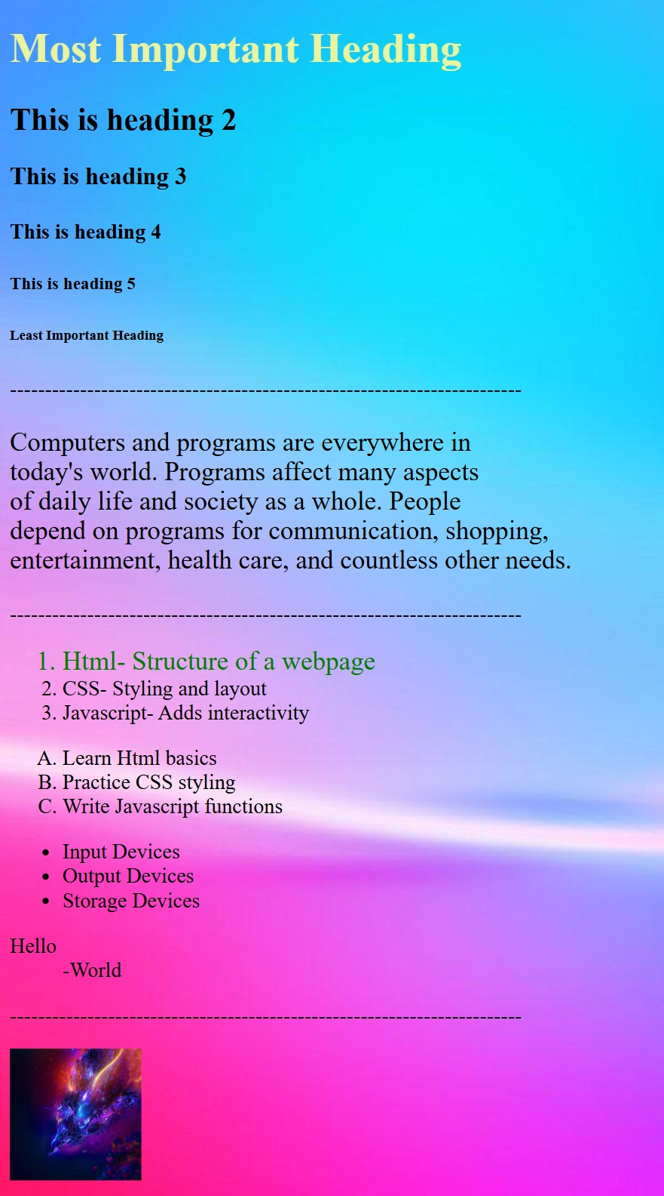

**Output:**